Chapter 5

**Results**

This chapter will discuss the results of various game mechanics and designs that were implemented such as the outcome of NavMesh incorporation, UI, Level design, animation, and resource monitoring.

**NavMesh**

Navigation meshing, or NavMesh has been incorporated into the game, giving the game’s main character’s A.I. a more “common sense” movement pattern when moving throughout the terrain.

For example, without NavMesh, the character would sometimes be prone to walking into inanimate objects such as boulders or trees as show in the image below. 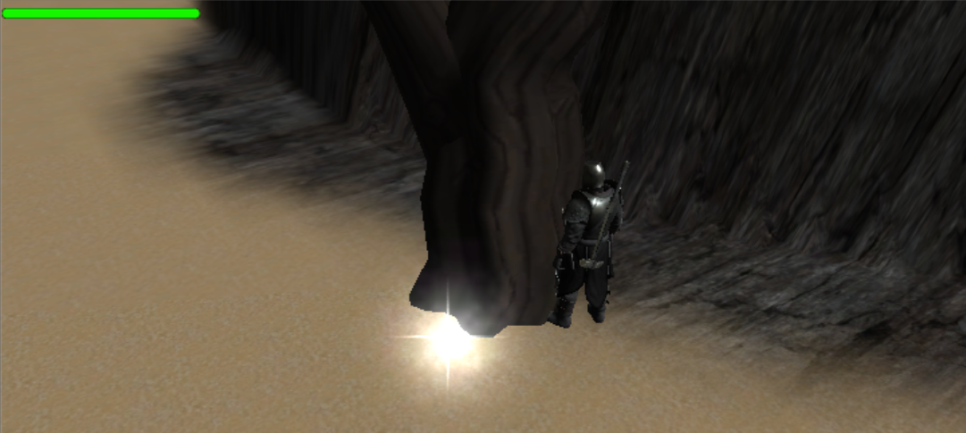

Even though these types of collision possibilities are not guaranteed, NavMeshing would almost completely eliminate these unintended interactions, giving the character more sensible movement patterns. 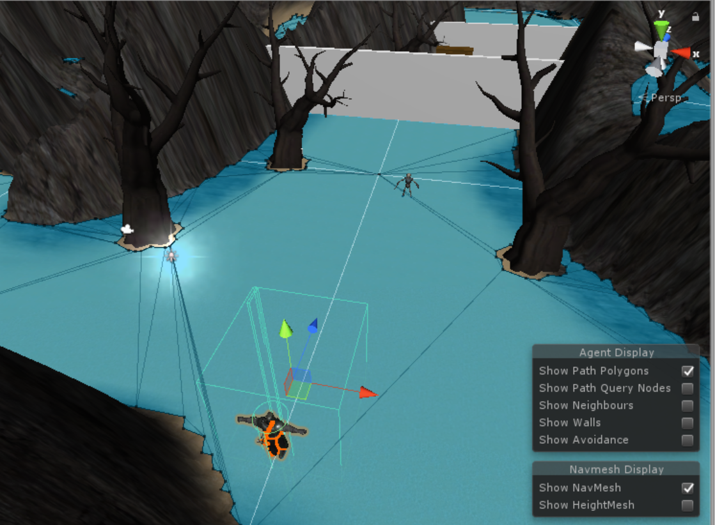

**Levels**

So far, two stages have been designed. The first stage takes place on the island of s1 where the goal is to get to the cave entrance. The stage has strategically placed enemies designed to hinder your progress throughout the stage. There is also a floor trap blocking your path to the cave entrance that must be deactivated by locating and pressing a button on an alternate path.

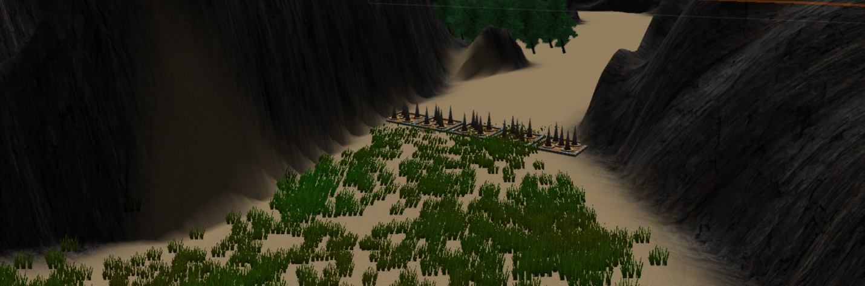

Also throughout the level, there are 3 chests spread around the stage. One is located right at the starting spot, another is hidden, and one is behind a spear-throwing trap that you must shut off using a hidden button.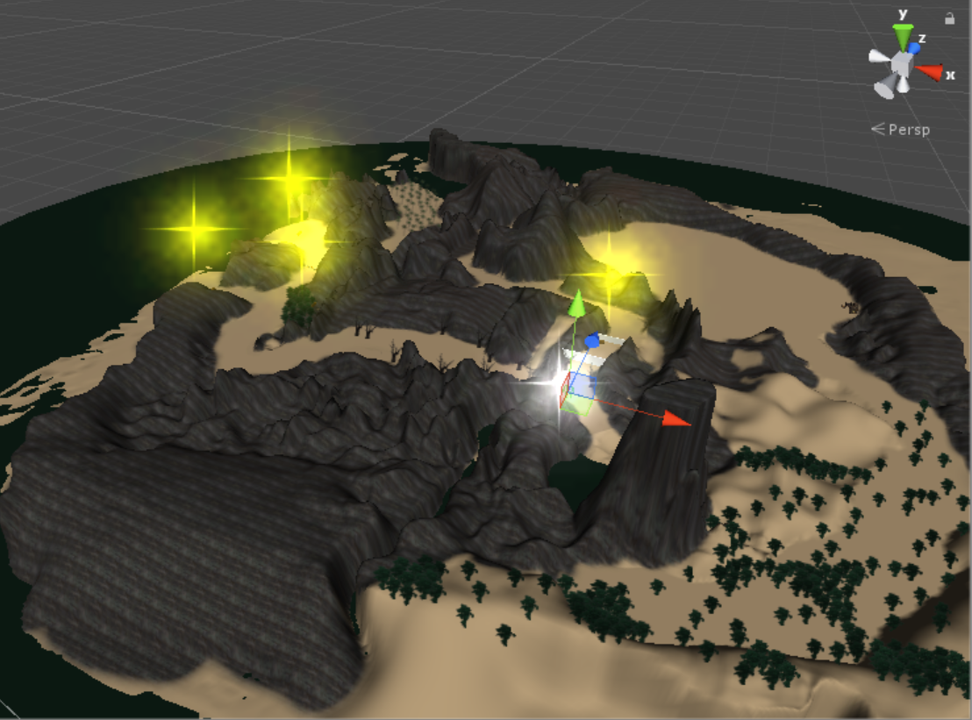

The second stage is the cave where there are two paths, one takes you through various enemies and leads towards a dead end with a chest that contains a power-up that allows the player-controlled character to illuminate the dark cave environment without the use of torches, and in the other direction is a button that shuts off a trap blocking the way out where the goal is located.

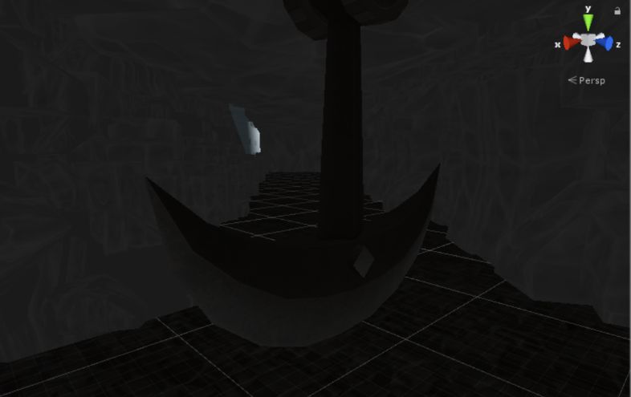

**Resources**

The games resource usage was able to be monitored using a third-party application called RivaTuner Statistics Server, which allowed viewing of CPU, GPU, memory, and framerate usage throughout the testing period.

Throughout the entire game’s development thus far, every facet of the game’s resource utilization has been consistently acceptable. So far, the game’s framerate has consistently stayed above 60 frames per second, average memory usage is currently at 2.6 GB, and both CPU and GPU utilization averages have been under 30 percent, although those numbers are expected to rise as more content is added into the game.

**Survey**

As noted in the survey chart below, ten participants were asked to review the game based on an alpha phase demonstration, rating categories such as graphics, smoothness, sound, difficulty, movement, and originality.

Chapter 6

**Conclusion**

This chapter will summarize the progress of the project so far and discuss future plans for further development of the game.

**Oculus Compatibility**

The Oculus Rift platform proved to be an arduous task. While trying to use the Oculus Rift, there were a multitude of compatibility errors that are in need of further evaluation in the future.

**Survey Analysis**

Based on the aforementioned survey, several improvements and suggestions have been noted and planned for future implementation.

The game’s framerate so far has been consistently at 60 frames per second and will be continuously monitored as new elements of the game are added and more resources are used.

The music and sound ratings had an understandably low average considering that at the time of the surveys, none of the music and few sound effects had been implemented, and these will be put in soon.

In terms of character design, additional characters are planned in future builds in order to give the game character diversity and help spice up the game’s character variety. The main character model has been updated with walking and attacking animations and a chicken dance that activates after a victorious battle.

The game’s menus are mostly completed with certain options such as volume control planned to be added.

While the main game’s user interface already has the most important parts added, the character’s health meter and game minimap, additions to the UI have been planned, such as a magic meter and statistics for the main character.

Comments about the game’s graphics, such as an apparent lack of color variety have been taken into consideration, and plans for additional ambient objects to be placed in the environment such as flora are planned to be implemented.

The winning conditions so far in the game’s alpha phase are only to reach the end point of the stage, but in the future, more objectives such as bounties, wave survival, and numerous side quests.